Exercises
- Selection - If
Ask the user to enter a percentage grade and return the grade. Use the leaving cert points system and assume only higher paper (for now!).
For example: User enters 65, H4 is returned


- Selection – Switch
Use a switch statement which accepts a grade such as H1 and returns the points.
For example: User enters H3 and 77 is returned
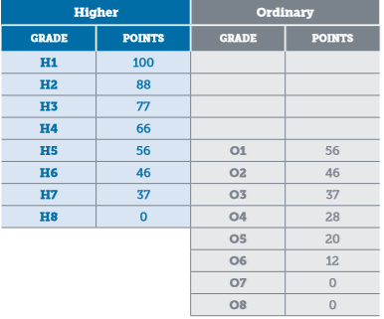

- Nested If
Amend exercise 1 above to ask for higher or ordinary level and calculate the points accordingly.
For example: User enters 75% higher and 77 is returned.

- For Loop
Add a for loop which will repeat 7 times and ask for results in each of 7 subjects. Keep a tally of the total number of points and display this at the end. Normally Leaving Cert results are comprised of 6 subjects. Amend so that the lowest number of points are discarded.

- While Loop
Use a while loop to continue to read results until a sentinel value of -1 is entered. You do not need to cater for discarding subjects and lowest here.

